Name : PRINCE RAJ

Enrolment No. : A12405218012

Class : 5CSE13X

Q. Write a python program to create a tuple

Code and Output:-

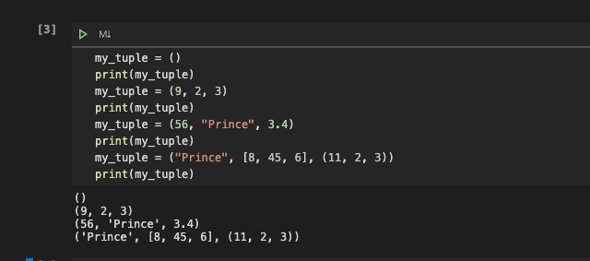

Q. Write a python program to create a tuple with different data types

Code and output:-

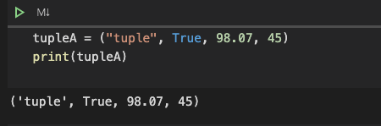

Q. Write a python program to create a tuple with numbers and print one item.

Code and output:

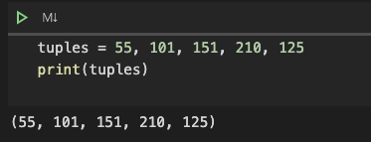

Q. Write a python program to add an item in a tuple.

Code and Output:

